Click here for instructions on how to save this script.

OVERVIEW
WHO
Target Audience | Who’s the target audience for this video?  Example: Cooking enthusiasts
WHY
Video Goal | What’s your video’s goal? State it as a solution to the viewer’s problem.  Example: Teach viewers how to make hot chocolate in a variety of ways.
Audience State  Before Watching | Example: I don’t know how to make hot chocolate. | Audience State  After Watching | Example: I now know how to make hot chocolate in three different ways.
HOW
Steps from Before to After | What will it take for the audience to achieve their goals? (What’s the mindset switch? Start with what they want, give them what they need)
WHERE |  | WHEN
Publishing Platforms | Where is this going to be posted?  YouTube  Instagram  LinkedIn  Facebook | Target Publish Date | When is the video scheduled to be posted? Indicate a date range if uncertain
WHAT
Content Category | What type of video is this? Example: Vlog/Educational/Business/Storydriven/Videography | Subtitles? | Yes/No
YOUTUBE
Published Video Title | Make sure your final title is concise and attention-grabbing.  Example: Homemade Hot Chocolate 3 Ways
Similar Videos/References | Send links to videos to emulate or are related to the topic.
Duration (mins) | How long is the video? | Exports &  Aspect Ratio | Indicate how many exports are needed and the aspect ratio for each.  Example:  1 Youtube (16:9)
Video Description | What is the video about? This is what will be placed in the description box on YouTube.  Include relevant social media links related to the creator’s socials.  Example:  Today I made all of the types of hot chocolate known to man. Or at least it felt like that. Really we made hot chocolate 3 different ways. Those ways being classic hot chocolate, Italian hot chocolate, and a spicy Mexican hot chocolate. So as it just begins to get chilly, let's get this hot chocolate party started.  0:00 - Intro  0:20 - Classic Hot Chocolate  1:30 - Italian Hot Chocolate  2:30 - Sponsors  2:45 - Mexican Hot Chocolate  Follow me on social media:  Facebook: facebook.com/johndoevideo  Instagram: instagram.com/@johndoevideo
Thumbnail Template | Attach photo here.  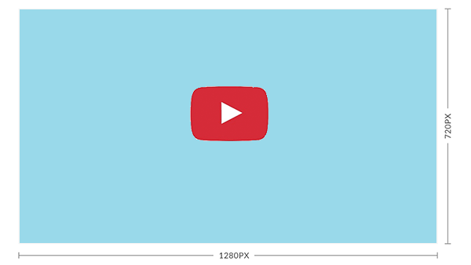 | Keywords / Tags | List 5-10 words that will attract search results to the video.  Example: cooking, chocolate, instructional, how-to, food, drinks, italy, mexico, dessert
INSTAGRAM
Published Video Title | Make sure your final title is concise and attention-grabbing.  Example: Homemade Hot Chocolate 3 Ways
Similar Videos/References | Send links to videos to emulate or are related to the topic.
Duration (mins) | How long is the video? | Exports &  Aspect Ratio | Indicate how many exports are needed and the aspect ratio for each.  Example:  1 IGTV (9:16)
Video Description | What is the video about? This is what will be placed in the description box of the video’s platform.  Include relevant social media links related to the creator’s socials.  Example:  Today I made all of the types of hot chocolate known to man. Or at least it felt like that. Really we made hot chocolate 3 different ways. Those ways being classic hot chocolate, Italian hot chocolate, and a spicy Mexican hot chocolate. So as it just begins to get chilly, let's get this hot chocolate party started.  Follow me on social media:  Facebook: facebook.com/johndoevideo  Instagram: instagram.com/@johndoevideo
Thumbnail Template | Attach photo here. | Keywords / Tags | List 5-10 words that will attract search results to the video.  Example: cooking, chocolate, instructional, how-to, food, drinks, italy, mexico, dessert
LINKEDIN
Published Video Title | Make sure your final title is concise and attention-grabbing.  Example: Homemade Hot Chocolate 3 Ways
Duration (mins) | How long is the video? | Exports &  Aspect Ratio | Indicate how many exports are needed and the aspect ratio for each.  Example:  1 LinkedIn (4:3)
Similar Videos/References | Send links to videos to emulate or are related to the topic.
Video Description | What is the video about? This is what will be placed in the description box of the video’s platform.  Include relevant social media links related to the creator’s socials.  Example:  Today I made all of the types of hot chocolate known to man. Or at least it felt like that. Really we made hot chocolate 3 different ways. Those ways being classic hot chocolate, Italian hot chocolate, and a spicy Mexican hot chocolate. So as it just begins to get chilly, let's get this hot chocolate party started.  Follow me on social media:  Facebook: facebook.com/johndoevideo  Instagram: instagram.com/@johndoevideo
Thumbnail Template | Attach photo here. | Keywords / Tags | List 5-10 words that will attract search results to the video.  Example: cooking, chocolate, instructional, how-to, food, drinks, italy, mexico, dessert

FACEBOOK
Published Video Title | Make sure your final title is concise and attention-grabbing.  Example: Homemade Hot Chocolate 3 Ways
Duration (mins) | How long is the video? | Exports &  Aspect Ratio | Indicate how many exports are needed and the aspect ratio for each.  Example:  1 Facebook (4:3)
Similar Videos/References | Send links to videos to emulate or are related to the topic.
Video Description | What is the video about? This is what will be placed in the description box of the video’s platform.  Include relevant social media links related to the creator’s socials.  Example:  Today I made all of the types of hot chocolate known to man. Or at least it felt like that. Really we made hot chocolate 3 different ways. Those ways being classic hot chocolate, Italian hot chocolate, and a spicy Mexican hot chocolate. So as it just begins to get chilly, let's get this hot chocolate party started.  Follow me on social media:  Facebook: facebook.com/johndoevideo  Instagram: instagram.com/@johndoevideo
Thumbnail Template | Attach photo here. | Keywords / Tags | List 5-10 words that will attract search results to the video.  Example: cooking, chocolate, instructional, how-to, food, drinks, italy, mexico, dessert

Video Script:
Time | Section | Script | Type
0:00 | Hook  - Done? | - Christmas is just around the corner, and you all know what that means: hot chocolate time.  - Today I’ll show you guys three different ways to make this popular holiday drink.  - First is the classic hot chocolate  - Second we’ll do italian cocoa  - Last but not the least - spicy mexican hot chocolate. | A-Roll
0:00 | Hook  - Done? |  | B-Roll
0:00 | Hook  - Done? |  | Audio
0:00 | Hook  - Done? |  | Graphics
0:00 | Hook  - Done? |  | Others
0:30 | Intro  - Done? | Youtube Intro:  - Hey guys, welcome back to my channel.  If you’re new here, my name is Chef John.  Let’s get cooking! | A-Roll
0:30 | Intro  - Done? |  | B-Roll
0:30 | Intro  - Done? |  | Audio
0:30 | Intro  - Done? |  | Graphics
0:30 | Intro  - Done? |  | Others
0:30 | Intro  - Done? | Instagram Intro:  - Hey followers, it’s Chef John back with a new cooking video. | A-Roll
0:30 | Intro  - Done? |  | B-Roll
0:30 | Intro  - Done? |  | Audio
0:30 | Intro  - Done? |  | Graphics
0:30 | Intro  - Done? |  | Others
0:40 | Main Content 1:  Classic Hot Chocolate  - Done? | 1. So this classic hot chocolate starts with putting 1 cup of milk into a saucepan.  2. Then we put 1 tablespoon of heavy cream.  3. 2 teaspoons of vanilla extract.  4. A quarter of a cup of brown sugar.  5. Then, 4 tablespoons of unsweetened cocoa powder.  6. Whisk that all together on medium-heat, until all your dry ingredients are dissolved and there are no lumps. | A-Roll
0:40 | Main Content 1:  Classic Hot Chocolate  - Done? |  | B-Roll
0:40 | Main Content 1:  Classic Hot Chocolate  - Done? |  | Audio
0:40 | Main Content 1:  Classic Hot Chocolate  - Done? |  | Graphics
0:40 | Main Content 1:  Classic Hot Chocolate  - Done? |  | Others
1:30 | Main Content 2:  Italian Hot Chocolate  - Done? | 1. Now for the italian hot chocolate, let’s add 1 cup of milk into a saucepan.  2. Then we put 1 tablespoon of heavy cream.  3. 2 teaspoons of vanilla extract.  4. A quarter of a cup of brown sugar.  5. Then, 4 tablespoons of unsweetened cocoa powder.  6. Whisk that all together on medium-heat, until all your dry ingredients are dissolved and there are no lumps. | A-Roll
1:30 | Main Content 2:  Italian Hot Chocolate  - Done? |  | B-Roll
1:30 | Main Content 2:  Italian Hot Chocolate  - Done? |  | Audio
1:30 | Main Content 2:  Italian Hot Chocolate  - Done? |  | Graphics
1:30 | Main Content 2:  Italian Hot Chocolate  - Done? |  | Others
2:30 | Ad Segment  - Done? | - This video is brought to you by Squarespace.  If you need a domain, website or online store, make it with Squarespace. | Graphics
2:30 | Ad Segment  - Done? |  | Audio
2:45 | Main Content 3:  Mexican Hot Cocoa  - Done? | 1.Last but not least - Mexican hot chocolate.  Start with 1 cup of milk into a saucepan.  2. Then we put 1 tablespoon of heavy cream.  3. 2 teaspoons of vanilla extract.  4. A quarter of a cup of brown sugar.  5. Then, 4 tablespoons of unsweetened cocoa powder.  6. Whisk that all together on medium-heat, until all your dry ingredients are dissolved and there are no lumps. | A-Roll
2:45 | Main Content 3:  Mexican Hot Cocoa  - Done? |  | B-Roll
2:45 | Main Content 3:  Mexican Hot Cocoa  - Done? |  | Audio
2:45 | Main Content 3:  Mexican Hot Cocoa  - Done? |  | Graphics
2:45 | Main Content 3:  Mexican Hot Cocoa  - Done? |  | Others
3:30 | Main Content 4: Closing  - Done? | - Well guys so that is it for hot chocolate.  - Now you’re just going to have to make it, ‘cause winter’s coming around and now is the best time to impress your family and friends with this simple & delectable drink.  - I have a couple more video recipes coming out that I want to reveal but can’t yet so stay tuned for those. | A-Roll
3:30 | Main Content 4: Closing  - Done? |  | B-Roll
3:30 | Main Content 4: Closing  - Done? |  | Audio
3:30 | Main Content 4: Closing  - Done? |  | Graphics
3:30 | Main Content 4: Closing  - Done? |  | Others
4:00 | Outro  - Done? | Youtube Outro:  - If you liked this video click that like, subscribe and hit the bell icon for notifs of my new uploads! | A-Roll
4:00 | Outro  - Done? |  | B-Roll
4:00 | Outro  - Done? |  | Audio
4:00 | Outro  - Done? |  | Graphics
4:00 | Outro  - Done? |  | Others
4:00 | Outro  - Done? | Instagram Outro:  - If you liked this video click that heart button or add it to your story! | A-Roll
4:00 | Outro  - Done? |  | B-Roll
4:00 | Outro  - Done? |  | Audio
4:00 | Outro  - Done? |  | Graphics
4:00 | Outro  - Done? |  | Others
4:20 | End card | N/A | Graphics
4:20 | End card | N/A | Audio

Technical Script:
This version of the script is meant to be a detailed guide for the editor.
TIME | VIDEO | AUDIO | GRAPHICS / TRANSITIONS
0:00 |  | [MUSIC] Channel Intro Theme.mp3 | Channel Intro.mp4
0:15 | [A-ROLL, Medium Shot] John center frame, talking to viewers | [DIALOGUE] So for today’s video we’re making three types of hot chocolate. Let’s get into it!
0:25 | [B-ROLL, Close-up] Hot chocolate poured into mug  [B-ROLL, Wide] Shot of mug with cocoa sprinkled on top  [Montage] Best shots of hot chocolate making process | [MUSIC] Relaxing jazz tune | [TEXT FADE IN] “Hot Chocolate”
0:40 | [A-ROLL] John tasting the drink | [VOICEOVER]  So first thing we’re going to make is the classic hot chocolate recipe. | [TEXT] Classic Hot Chocolate
 | [B-ROLL] Chronological footage of recipe instructions | [VOICEOVER] Recipe is as follows.  [MUSIC] subtle background music
5:00 | [A-ROLL] Shot of John speaking to viewers  [B-ROLL] Close-up shots of mexican hot chocolate & italian hot chocolate as mentioned | [DIALOGUE] The verdict of these recipes for me - the mexican and italian hot chocolate recipes are by far my favorite.
5:15 | [BLACK SCREEN] | [VOICEOVER] But do you want to know what else is a winner? B-roll.
5:18 | [B-ROLL] Montage of melting chocolate & finished products | [MUSIC] Relaxing jazz instrumental
5:33 | [A-ROLL] John speaking to viewers | [DIALOGUE] Alright guys, that’s it for the video. Now that winter’s coming around, it’s a good time to start making your own hot chocolate at home. With that said, if you enjoyed this video please leave a like, subscribe and hit that bell icon to get notified when I upload a new one. I’ll see you all next time!
6:00 |  |  | (fade in)  [ENDCARD] “JOHN DOE COOKING” Logo center frame

Shot List:
List down each shot needed for the video. This will serve as a checklist during filming to ensure all bases are covered.

Shot # | Interior/Exterior | Shot | Camera Angle | Camera Motion | Audio | Shot Description | Done?
1 | Interior | Medium | Eye-level | None | Shotgun Mic | YT Intro | X
2 | Interior | Medium | Eye-level | None | Shotgun Mic | IG Intro
3 | Interior | Medium | Eye-level | None | Shotgun Mic | LinkedIn Intro
4 | Interior | Close-up | Overhead | Slow Zoom-in | None | B-Roll of mug
5 | Interior | Medium | Eye-level | None | Shotgun Mic | YT Outro
6 | Interior | Medium | Eye-level | None | Shotgun Mic | IG Outro
7 | Interior | Medium | Eye-level | None | Shotgun Mic | LinkedIn Outro

How to Save This Script
To transfer to your Google Drive, click file on the menu then select make a copy.

If you don't use Google Drive, you can also download and save it as a Microsoft Word document.

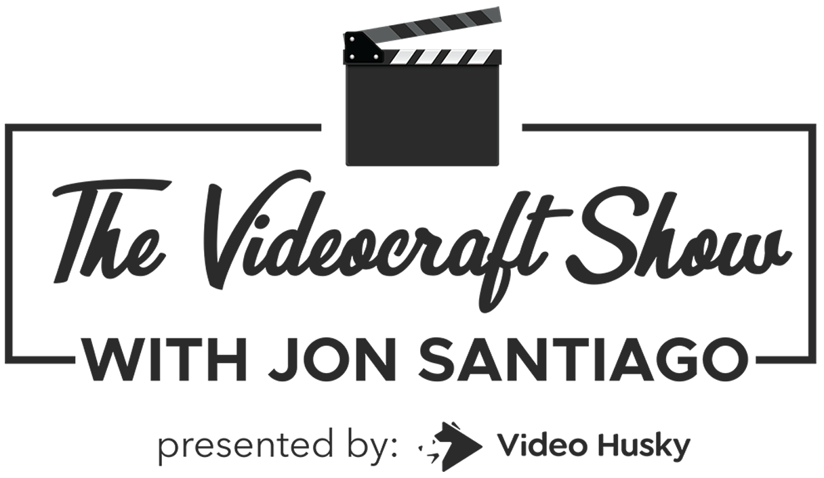

This script is brought to you by The Videocraft Show Presented By Video Husky. It's weekly podcast about the craft and business
of content creation. Hear stories from makers and creators about how they're building audiences through video.

Listen to The Videocraft Show Presented By Video Husky on:
🎧 Spotify
🎧 Apple Podcasts
🎧 Google Podcasts
🎧 Castbox
🎧 Stitcher
🎧 Amazon Music
🎧 Pocketcasts
🎧 Overcast
🎧 YouTube
🎧 iHeartRadio
🎧 Radio.com

