The Eugenics Roots of the Great Reset (How the Unthinkable Became Thinkable)
As much as it might cause us a fair deal of displeasure and even an upset stomach to consider such ideas as the hold eugenics has on our presently troubled era, I believe that ignoring such a topic really does no one any favors in the long run.
This is especially serious, as leading World Economic Forum darlings like Yuval Harari flaunt such concepts as “the new global useless class” which Artificial intelligence, genetic engineering, automation and the Fourth Industrial Revolution is supposedly ushering in.
VIDEO CLIP OF HARARI SAYING GROSS STUFF
Other Davos creatures like Klaus Schwab call openly for a microchipped global citizenry capable of interfacing with a global web with a single thought
VIDEO CLIP OF SCHWAB
while Elon Musk and Mark Zuckerberg promote ‘neuralinks’ to “keep humanity relevant” by merging with computers in a new epoch of evolutionary biology.
SCREENSHOT OF MUSK QUOTE
Leading Darwinian geneticists like Sir James Watson and Sir Richard Dawkins openly defend eugenics while a technocracy consolidates itself in a governing station using a “Great Reset” as an excuse to usher in a new post-nation state era.
SCREEN SHOT OF WATSON AND DAWKINS PRO-EUGENICS statements or video clips
If there is something fundamentally evil lurking behind these processes which has any connection to the Anglo-American rise of fascism and eugenics nearly a century ago, then let’s at least have the courage to explore that possibility. It was after all, only by looking at this ugliness 80 years ago, that patriots were able to take appropriate measures to prevent a bankers’ technocratic dictatorship in 1933 and again during WW2.. so perhaps a similar display of courage to think the unthinkable might be worth the effort for those who might find themselves in a similar situation today.
IMAGE OF FDR, DeGaulle, Stalin etc WW2 pics
It is among the greatest scandals of our age that the Wall Street- City of London machine that financed Hitler and Mussolini as battering rams for a new world order were never actually brought to justice.
PIC of either Prescott and Hitler/Schacht or King Edward 8 with Hitler
Although Franklin Roosevelt managed to put a leash on Wall Street between 1933-1945, while setting the world stage for a beautiful post-war vision of win-win cooperation, the darker forces of the financier oligarchy who wanted only to establish a global unipolar system of governance not only avoided punishment, but wasted no time to regain their lost hegemony before the war had come to a close.
Pics of Xi, Putin, BRI Maps?
Act 1: The Uncomfortable Truth of WW2
Adolph Hitler or Benito Mussolini were never “their own men”.
The machines they led were never fully under their sovereign control and the financing they used as fuel in their effort to dominate the world did not come from the Banks of Italy or Germany. The technologies they used in petrochemicals, rubber, and computing didn’t come from Germany or Italy, and the governing scientific ideology of eugenics that drove so many of the horrors of Germany’s racial purification practices never originated in the minds of German thinkers or from German institutions.
Were it not for a powerful network of financiers and industrialists of the 1920s-1940s with names such as Rockefeller, Warburg, Montague Norman, Osborn, Morgan, Harriman or Dulles, then it can safely be said that fascism would never have been possible as a “solution” to the economic woes of the post-WWI order. To prove this point, let us take the strange case of Prescott Bush as a useful entry point.
[Pics of wargburgs, Norman, Osborn, Dulles, Rockefeller etc]
The patriarch of the same Bush dynasty that gave the world two disastrous American presidents (and nearly a third had Donald Trump not annihilated Jeb at the last minute in 2016) made a name for himself funding Nazism alongside his business partners Averell Harrimen and Averell’s younger brother E. Roland Harriman (the latter who was to recruit Prescott to Skull and Bones while both studying at Yale). Not only did Prescott, acting as director of Brown Brothers Harriman, provide valuable loans to keep the bankrupt Nazi party afloat during Hitler’s loss of support in 1932 when the German population voted into office the anti-Fascist General Kurt von Schleicher as Chancellor, but was even found guilty for “Trading with the enemy” as director of Union Banking Corporation in 1942!
Pic of characters Harrimans, Prescott, newspaper clip of Prescott tading with enemy etc
That’s right! As demonstrated in the 1992 Unauthorized Biography of George Bush, eleven months after America entered WWII, the Federal Government naturally conducted an investigation of all Nazi banking operations in the USA and wondered why Prescott continued to direct a bank which was so deeply enmeshed with Fritz Thyssen’s Bank voor Handel en Scheepvart of the Netherlands. Thyssen for those who are un-aware is the German industrial magnate famous for writing the book “I Paid Hitler”. The bank itself was tied to a German combine called Steel Works of the German Steel Trust which controlled 50.8% of Nazi Germany’s pig iron, 41.4% of its universal plate, 38.5% of its galvanized steel, 45.5% of its pipes and 35% of its explosives. Under Vesting Order 248, the U.S. federal government seized all of Prescott’s properties on October 22, 1942.
[cover of Chaitkin book, and I paid Hitler book maybe pic of Fritz Thyssen and Bank voor Handel logo]
The U.S.-German Steel combine was only one small part of a broader operation as Rockefeller’s Standard Oil had created a new international cartel alongside IG Farben (the fourth largest company in the world) in 1929 under the Young Plan.
[Image of young plan delegates]
Owen Young was a JP Morgan asset who headed General Electric and instituted a German debt repayment plan in 1928 that gave rise to the Bank of International Settlements (BIS) and consolidated an international cartel of industrialists and financiers on behalf of the City of London and Wall Street. The largest of these cartels saw Henry Ford’s German operations merging with IG Farben, Dupont industries, Britain’s Shell and Rockefeller’s Standard Oil. The 1928 cartel agreement also made it possible for Standard Oil to pass off all patents and technologies for the creation of synthetic gasoline from coal to IG Farben thus allowing Germany to rise from producing merely 300 000 tons of natural petroleum in 1934 to an incredible 6.5 million tons (85% of its total) during WWII! Had this patent/technology transfer not taken place, it is a fact that the modern mechanized warfare that characterized WWII could never have occurred.
Two years before the Young Plan began, JP Morgan had already given a $100 million loan to Mussolini’s newly established fascist regime in Italy- with Democratic Party kingmaker Thomas Lamont playing the role of Prescott Bush in Wall Street’s Italian operation. It wasn’t only JP Morgan who loved Mussolini’s brand of corporate fascism, but Time Magazine’s Henry Luce unapologetically gushed over Il Duce putting Mussolini on the cover of Time eight times between 1923 and 1943 while relentlessly promoting fascism as the “economic miracle solution for America” (which he also did in his other two magazines Fortune and Life). Many desperate Americans, still traumatized from the long and painful depression begun in 1929, had increasingly embraced the poisonous idea that an American fascism would put food on the table and finally find help them find work.
A few words should be said of Brown Brothers Harriman.
Bush’s Nazi bank itself was the spawn of an earlier 1931 merger which took place between Montagu Norman’s family bank (Brown Brothers) and Harriman, Bush and Co. Montague Norman was the Governor of the Bank of England from 1920 to 1944, leader of the Anglo-German Fellowship Trust and controller of Germany’s Hjalmar Schacht (Reichsbank president from 1923-1930 and Minister of Economy from 1934-1937). Norman was also the primary controller of the Bank of International Settlements (BIS) from its creation in 1930 throughout the entirety of WWII.
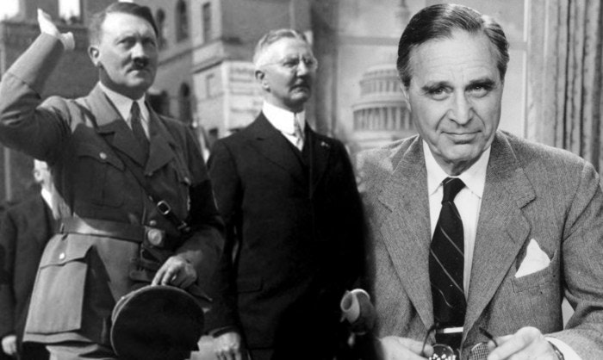
The Central Bank of Central Banks
Although the BIS was established under the Young Plan and nominally steered by Schacht as a mechanism for debt repayments from WWI, the Swiss-based “Central Bank of Central Banks” was the key mechanism for international financiers to fund the Nazi machine. The fact that the BIS was under the total control of Montagu Norman was revealed by Dutch Central Banker Johan Beyen who said “Norman’s prestige was overwhelming. As the apostle of central bank cooperation, he made the central banker into a kind of arch-priest of monetary religion. The BIS was, in fact, his creation.”
The founding members of the Board included the private central banks of Britain, France, Germany, Italy and Belgium as well as a coterie of 3 private American banks (JP Morgan, First National of Chicago, and First National of New York). The three American banks merged after the war and are today known as Citigroup and JP Morgan Chase.
In its founding constitution, the BIS, its directors and staff were given immunity from all sovereign national laws and not even authorities in Switzerland were permitted to enter its premises.
This story was conveyed powerfully in the 2013 book Tower of Basel: The Shadowy History of the Secret Bank that Runs the World.
A Word on Eugenics
Nazi support in the build up to, and during WWII didn’t end with finance and industrial might, but extended to the governing scientific ideology of the third Reich: Eugenics (aka: the science of Social Darwinism as developed by Thomas Huxley’s X Club associate Herbert Spencer and Darwin’s cousin sir Francis Galton decades earlier).
In 1932, New York hosted the Third Eugenics Conference co-sponsored by William Draper Jr (JP Morgan banker, head of General Motors and leading figure of Dillon Read and co) and the Harriman family. This conference brought together leading eugenicists from around the world who came to study America’s successful application of eugenics laws which had begun in 1907 under the enthusiastic patronage of Theodore Roosevelt. Hiding behind the respectable veneer of “science” these high priests of science discussed the new age of “directed evolution of man” which would soon be made possible under a global scientific dictatorship.
Speaking at the conference, leading British Fascist Fairfield Osborn said that eugenics:
“Aids and encourages the survival and multiplication of the fittest; indirectly, it would check and discourage the multiplication of the unfitted. As to the latter, in the United States alone, it is widely recognized that there are millions of people who are acting as dragnets or sheet anchors on the progress of the ship of state…While some highly competent people are unemployed, the mass of unemployment is among the less competent, who are first selected for suspension, while the few highly competent people are retained because they are still indispensable. In nature, these less-fitted individuals would gradually disappear, but in civilization, we are keeping them in the community in the hopes that in brighter days, they may all find employment. This is only another instance of humane civilization going directly against the order of nature and encouraging the survival of the un-fittest”.
The dark days of the great depression were good years for bigotry and ignorance as eugenics laws were applied to two Canadian provinces, and widely spread across Europe and America with 30 U.S. states applying eugenics laws to sterilize the unfit. Eugenics’ successful growth was due in large measure to the fierce financial support of the Rockefeller Foundation and the science magazine Nature which had been created in 1865 by T.H. Huxley’s X Club. The Rockefeller Foundation went onto fund German eugenics and most specifically the rising star of human improvement Joseph Mengele.
The Nazi Frankenstein Monster is Aborted
Describing his January 29, 1935 meeting with Hitler, Round Table controller Lord Lothian quoted the Fuhrer’s vision for Aryan co-direction of the New World Order saying:
“Germany, England, France, Italy, America and Scandinavia … should arrive at some agreement whereby they would prevent their nationals from assisting in the industrializing of countries such as China, and India. It is suicidal to promote the establishment in the agricultural countries of Asia of manufacturing industries”
While it is obvious that much more can be said on the topic, the Fascist machine didn’t fully behave the way the Dr. Frankensteins in London wished, as Hitler began to realize that his powerful military machine gave Germany the power to lead the New World Order rather than play second fiddle as mere enforcers on behalf of their Anglo masters in Britain. While many London and Wall Street oligarchs were willing to adapt to this new reality, a decision was made to abort the plan, and try to fight another day.
To do this a scandal was concocted to justify the abdication of pro-Nazi King Edward VIII in 1936 and an appeasing Prime Minister Neville Chamberlain was replaced with Winston Churchill in 1940. While Sir Winston was a life long racist, eugenicist and even Mussolini-admirer, he was first and foremost a devout British Imperialist and as such would fight tooth and nail to save the prestige of the Empire if it were threatened. Which he did.
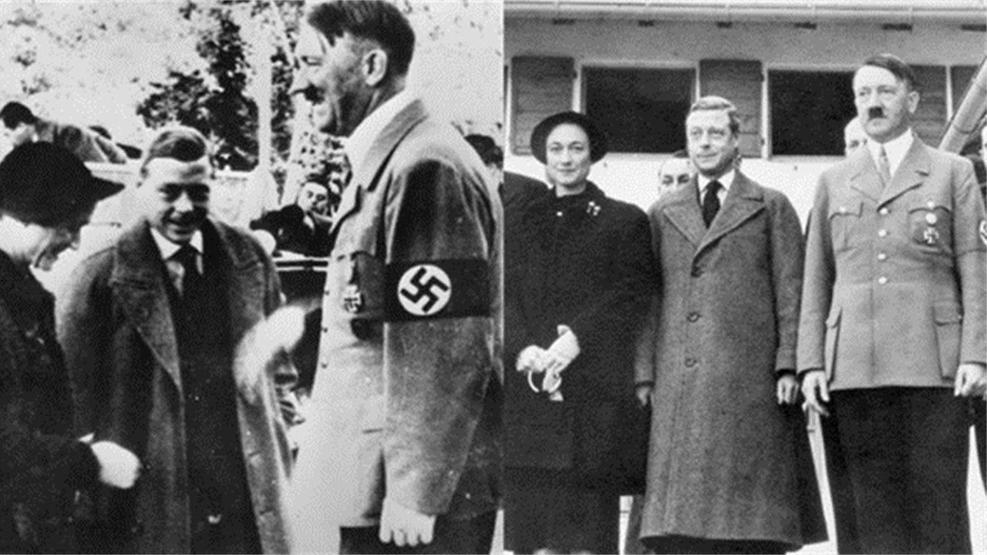
The Fascists vs Franklin Roosevelt
Within America itself, the pro-fascist Wall Street establishment had been loosing a war that began the day anti-fascist President Franklin Roosevelt was elected in 1932. Not only had their attempted February 1933 assassination failed, their 1934 coup d’etat plans were also thwarted by a patriotic General named Smedley Darlington Butler. To make matters worse, their efforts to keep America out of the war in the hopes of co-leading the New World Order alongside Germany, France and Italy was also falling apart. Between 1933-1939, FDR had imposed sweeping reforms on the banking sector, thwarted a major attempt to create a global Bankers’ dictatorship under the Bank of International Settlements [FN], and mobilized a broad recovery under the New Deal.
By 1941, Japan’s attack on Pearl Harbor polarized the American psyche so deeply that resisting America’s entry into WWII as Wall Street’s American Liberty League had been doing up until then, became political suicide. Wall Street’s corporatist organizations were called out by FDR during a powerful 1938 speech as the president reminded the Congress of the true nature of fascism:
“The first truth is that the liberty of a democracy is not safe if the people tolerate the growth of private power to a point where it becomes stronger than their democratic state itself. That, in its essence, is fascism – ownership of government by an individual, by a group, or by any other controlling private power… Among us today a concentration of private power without equal in history is growing. This concentration is seriously impairing the economic effectiveness of private enterprise as a way of providing employment for labor and capital and as a way of assuring a more equitable distribution of income and earnings among the people of the nation as a whole.”
While America’s entry into WWII proved a decisive factor in the destruction of the fascist machine, the dream shared by Franklin Roosevelt, Henry Wallace and many of FDR’s closest allies across America, Canada, Europe, China and Russia for a world governed by large-scale development, and win-win cooperation did not come to pass.
Even though FDR’s ally Harry Dexter White led in the fight to shut down the Bank of International Settlements during the July 1944 Bretton Woods conference, the passage of White’s resolutions to dissolve BIS and audit its books were never put into action. While White, who was to become the first head of the IMF, defended FDR’s program to create a new anti-imperial system of finance, Fabian Society leader, and devout eugenicist John Maynard Keynes defended the Bank and pushed instead to redefine the post-war system around a one world currency called the Bancor, controlled by the Bank of England and BIS.
The Fascist Resurgence in the Post-War World
By the end of 1945, the Truman Doctrine and Anglo-American “special relationship” replaced FDR’s anti-colonial vision, while an anti-communist witch hunt turned America into a fascist police state under FBI surveillance. Everyone friendly to Russia was targeted for destruction and the first to feel that targeting were FDR’s close allies Henry Wallace and Harry Dexter White whose 1948 death while campaigning for Wallace’s presidential bid put an end to anti-colonialists running the IMF.
In the decades after WWII, those same financiers who brought the world fascism went straight back to work infiltrating FDR’s Bretton Woods Institutions such as the IMF and World Bank, turning them from tools of development, into tools of enslavement. This process was fully exposed in the 2004 book Confessions of an Economic Hit man by John Perkins.
Sir Julian Huxley and the Reawakening of Sleeping Monsters
One of the conceptual grand strategists of this process was a man named Julian Sorrel Huxley (1887-1975). Celebrated as a biologist, and social reformer, Julian was a devout life-long member of the British Eugenics Society serving alongside John Maynard Keynes as secretary and later as its president.
Julian was a busy man, who along with his brother Aldous, worked hard to fill the very large shoes of their grandfather Thomas [FN on X Club article from Nexus]. While simultaneously managing the post-WW2 eugenics movement, Julian found himself setting into motion the modern environmental movement as founder of the International Union for the Conservation of Nature in 1948, co-founding the World Wildlife Fund in 1961, created the term “transhumanism” and also founding an immensely influential United Nations body called UNESCO (abbreviated for the United Nations Education, Science and Cultural Organization) in 1946 which he ran as Director General from 1946-1948.
The mandate for the new organization was set out clearly in Huxley’s 1946 UNESCO: Its Purpose and Its Philosophy:
“The moral for UNESCO is clear. The task laid upon it of promoting peace and security can never be wholly realised through the means assigned to it- education, science and culture. It must envisage some form of world political unity, whether through a single world government or otherwise, as the only certain means of avoiding war… in its educational programme it can stress the ultimate need for a world political unity and familiarize all peoples with the implications of the transfer of full sovereignty from separate nations to a world organization.”
To what end would this “world political unity” be aimed? Several pages later, Huxley’s vision is laid out in all of its twisted detail:
“At the moment, it is probable that the indirect effect of civilization is dysgenic instead of eugenic, and in any case it seems likely that the dead weight of genetic stupidity, physical weakness, mental instability and disease proneness, which already exist in the human species will prove too great a burden for real progress to be achieved. Thus even though it is quite true that any radical eugenic policy will be for many years politically and psychologically impossible, it will be important for UNESCO to see that the eugenic problem is examined with the greatest care and that the public mind is informed of the issues at stake so that much that is now unthinkable may at least become thinkable.”
After the world got the chance to see what a eugenics program looked like under the full support of a fascist social engineer, it would be no exaggeration to say that it lost a good deal of popularity in the eyes of a world population still very much connected to traditional cultural institutions like Christianity, patriotism and respect for sacredness of life. As Huxley iterated in his manifesto, something new had to be done.
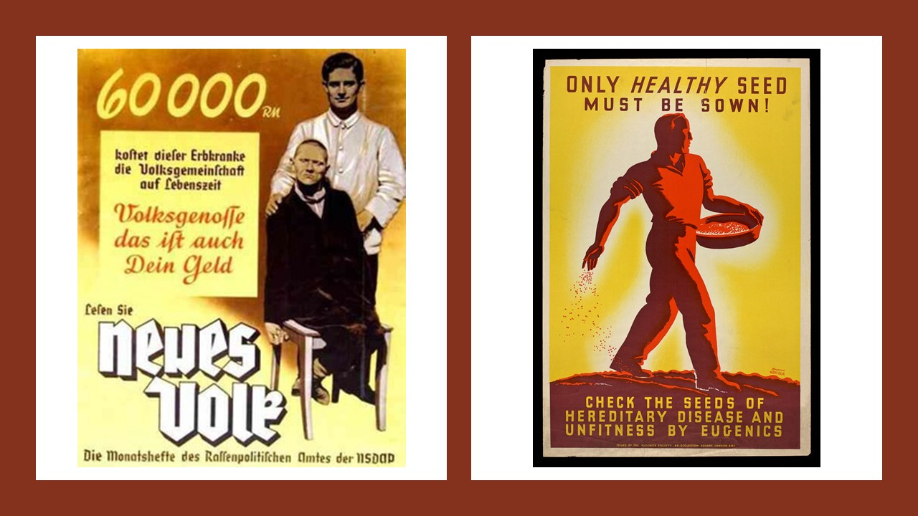
A Word on Tavistock
Huxley also worked very closely with London’s Tavistock Clinic that received funding from both Rockefeller and Macy Foundations throughout the 1930s-1950s. Led by a psychiatrist named Brigadier General John Rawlings Rees, Tavistock can be best understood as the “psychiatric branch of the British Empire” established in 1921 which innovated psychiatric techniques using mixtures of Pavlovian behaviorism and Freudian theories to influence group behavior in a variety of ways.
Early on, the clinic explored the extreme mental conditions of shell shock victims who suffered cases of psychological deconstruction during the terrors of trench warfare recognizing the high degree of malleability in these subjects. As outlined by a brilliant 1996 EIR report by L. Wolfe, the idea behind Tavistock’s was always driven by a goal to figure out how the brain might be “depatterned” and deconstructed in order to be reconstructed anew like a blank slate with the hopes that this insight into individuals might be replicated later among broader social groups, and even whole nations. Many of this research was applied in the form of MK Ultra within the USA and will be the subject of a future report.
G. Brock Chisholm: Tavistockian Czar of World Health
One prominent psychiatrist who spent years working under Rees at Tavistock was a Canadian named G. Brock Chisholm.

In 1948, Chisholm founded a UN-affiliated body called the World Health Organization (WHO) with the aim of promoting mental and physical health of the world. A noble endeavor carrying much responsibility and power requiring a leader with exceptional insight into the nature of sickness and health. Sadly, based upon his own sick views of the nature of mankind and society, Chisholm was certainly the wrong man for the job.
Among the greatest causes of war and mental sickness in Chisholm’s mind were not to be found in imperialism or economic injustice, but rather in society’s belief in right and wrong. Writing in 1946 Chriholm laid out the purpose of “good” psychotherapy and education saying: “the reinterpretation and eventual eradication of the concept of right and wrong which has been the basis of child training, the substitution of intelligent and rational thinking for faith in the certainties of old people- these are the belated objectives of practically all effective psychotherapy”.
But it wasn’t simply the “concept of right and wrong” or “faith in the certainties of old people” which had to be eradicated, but monotheistic religion, family, and patriotism. Speaking eight years later, Chisholm said: “To achieve world government, it is necessary to remove from the minds of men their individualism, loyalty to family tradition, national patriotism and religious dogmas”.
The World Goes Mental
Once UNESCO and the WHO were firmly in place, a third organization was created to drive the funding, and the practice of global mental health.
As outlined by historian Anton Chaitkin, funded primarily by the Macy Foundation, the World Federation of Mental Health (WFMH) was created in 1948. The Macy Foundation itself which was created in 1930 under the leadership of General Marlborough Churchill (cousin to Winston) who had been in charge of covert military intelligence from 1919-1929 in the form of the “Black Chamber”. His new foundation was a part of the Rockefeller machine and used as a conduit to pour money into “health sciences” with a focus on eugenics.
The U.S. technical coordinator to the conference that created the WFMH made the new organization’s origins clearly known. Nina Ridnour wrote “the World Federation for Mental Health… had been created upon the recommendation of the United Nations World Health Organization and UNESCO because they needed a non-governmental mental health organization with which they could cooperate.”
And just who would become the first Director General of the WFMH?
While still acting as the head of London’s Tavistock Clinic, Brigadier General John Rawlings Rees was put in charge of the new body by none other than arch-racist Montagu Norman (head of the Bank of England) who had created the operation out of his National Association for Mental Health run out of his London Thorpe Lodge home.
Describing this strategic battle plan to reform society, Rees said:
“If we prepare to come out into the open and to attack the social and national problems of our day, then we must have the shock troops, and these cannot be provided by psychiatry based wholly in institutions. We must have mobile teams of psychiatrists who are free to move around and make contacts with the local area.”
The idea of mobile teams of psychiatric shock troops was an idea advanced by leading grand strategist Lord Bertrand Russell who had written in 1952’s “Impact of Science on Society”:
“I think the subject which will be of most importance politically is mass psychology…. Its importance has been enormously increased by the growth of modern methods of propaganda. Of these the most influential is what is called “education.” Religion plays a part, though a diminishing one; the press, the cinema, and the radio play an increasing part…. It may be hoped that in time anybody will be able to persuade anybody of anything if he can catch the patient young and is provided by the State with money and equipment.”
The Bi-Polar Cold War and a New Global Paradigm
Over the ensuing years, UNESCO, the WHO and WFMH worked in tandem to coordinate hundreds of influential sub organizations, universities, research labs, and covert science including the CIA’s MK Ultra in order to bring about the desired “mentally healthy” society cleansed of its connections to Christianity, faith in truthfulness, national patriotism or family.
By 1971, the world was ripe for a big change.
The baby boomer targets of this vast social engineering experiment had been inundated by a vast arsenal of cultural warfare on every level. While LSD was spread across campuses of America, and assassinations of western leaders who resisted the new age of wars in Southwest Asia became the norm, the baby boomers watched as their loved ones returned from Vietnam in body bags. “Not trusting anyone over 30” became the new wisdom as love of country was suffocated under the unnatural spread of Anglo-American imperialism abroad and COINTEL PRO-style operations at home.
When the CFR and Trilateral Commission unpegged the U.S. dollar from the gold reserve, a new age of deregulation, consumerism and radical materialism was ushered in causing the baby boomer generation to quickly transmogrify into the 1980s hyper-materialist “me” generation.
On an ecological level, a new ethic of “conservationism” had begun to move from the fringes into the mainstream replacing the former pro-industrial ethic of the producer-creator society that had historically governed the best of western civilization.
Chief among the creators of this new conservation ethic which replaced the idea of “protecting humanity from empire” with “protecting nature from mankind”, was none other than Julian Huxley himself. During the same year that he co-founded the World Wildlife Foundation in order to provide income to the International Union for the Conservation of Nature. Huxley drafted the Morges Manifesto (1961) as the organizing manifesto for the modern ecology movement pitting human civilization in stark contrast to the supposedly closed, mathematical equilibrium of nature. Huxley co-founded the WWF with arch Malthusians Prince Philip “I want to be reincarnated as a deadly virus” Mountbatten and Prince Bernhard of the Netherlands.
“Flattening the Curves”: Predictive Modelling Replace Thinking
Where the future had formerly been understood as the effect of intentions, goals and ideas generated by the will and minds of creative human beings, the “new wisdom” of the new ecology movements involved simple linear extrapolations of questionable data sets into the future in order to create horrifying scenarios that would scare the masses into behavioral modification.
In earlier ages, The British Empire’s Thomas Malthus had justified population control of India, Ireland, and other parts of the world by extrapolating population growth trends into the future (predicting crises points that could only be mitigated if curves were flattened.
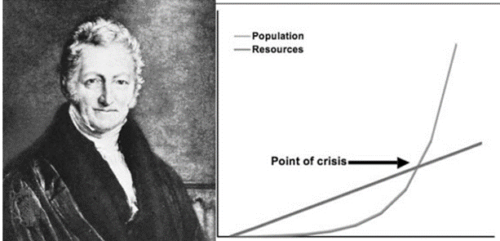
Although the burst of creative and technological progress during the middle-end 19th century set Malthus’ dismal theories out of fashion for the majority of humanity, they were re-packaged and revived again with the rise of Darwinism and the social extension of Darwin’s thesis onto human civilization as Francis Galton (the founder of eugenics) had extrapolated factors like criminality and low IQ of parents and great grandparents into the unborn future progeny of criminals or “imbiciles” of the early 20th century. This fallacy ignored all factors of imperialism and economic injustice that shaped the cultural field in which poor and desperate people were led into criminality or low intelligence while social engineers justified mass sterilization based on mathematical probabilities.
Under the guise of Huxley’s new ecology movement, new organizations like the Club of Rome were brought online which funded studies like Limits to Growth (1972) that extrapolated “pollution” and population growth into the future without accounting for the existence of non-linear human creative mentation that had given rise to all leaps in scientific and technological progress for thousands of years. Under the Club of Rome/WWF wisdom, human beings were to be confined to the same ecologically-determined “carrying capacities” as every other species of the biosphere.
One of the founding members of the Club of Rome (and also a Vice President of the World Wildlife Fund from 1976-1978) was a Canadian misanthrope named Maurice Strong who let the cat out of the bag in a 1990 interview musing:
“What if a small group of world leaders were to conclude that the principal risk to the Earth comes from the actions of the rich countries? And if the world is to survive, those rich countries would have to sign an agreement reducing their impact on the environment. Will they do it? The group’s conclusion is ‘no’. The rich countries won’t do it. They won’t change. So, in order to save the planet, the group decides: Isn’t the only hope for the planet that the industrialized civilizations collapse? Isn’t it our responsibility to bring that about?”
That same year, the Club of Rome’s founder Sir Alexander King had also admitted that the foundations of the new conservationist paradigm that his organization ushered into the world was premised on an intention to control the population. In the preface to The First Global Revolution,
“In searching for a new enemy to unite us, we came up with the idea that pollution, the threat of global warming, water shortages, famine and the like would fit the bill….All these dangers are caused by human intervention, and it is only through changed attitudes and behavior that they can be overcome. The real enemy then, is humanity itself.”
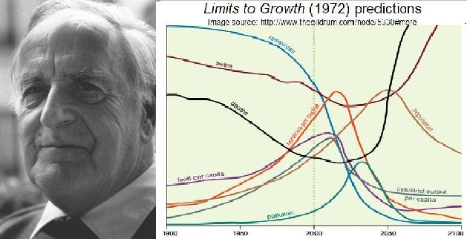

Holdren’s Planetary Regime
One of the leading neo-Malthusians that emerged in this process was named Paul Ehrlich who mentored a young protégé named John Holdren. Together, both men produced a stomach-turning manual called Ecoscience: Population, Resources, Environment in 1977 where the pair wrote:
“Perhaps those agencies, combined with UNEP and the United Nations population agencies, might eventually be developed into a Planetary Regime- sort of an international superagency for population, resources, and environment. Such a comprehensive Planetary Regime could control the development, administration, conservation, and distribution of all-natural resources, renewable or non-renewable, at least insofar as international implications exist. Thus, the Regime could have the power to control pollution not only in the atmosphere and oceans, but also in such freshwater bodies as rivers and lakes that cross international boundaries or that discharge into the oceans. The Regime might also be a logical central agency for regulating all international trade, perhaps including assistance from DCs to LDCs, and including all food on the international market. The Planetary Regime might be given responsibility for determining the optimum population for the world and for each region and for arbitrating various countries’ shares within their regional limits. Control of population size might remain the responsibility of each government, but the Regime would have some power to enforce the agreed limits.”
Considering that these words were written just three years after Henry Kissinger’s NSSM-200 report that transformed U.S. foreign policy doctrine from pro-development to pro-population reduction, Holdren’s 1977 words should not be taken lightly.
The Human Genome Project Revives Sleeping Monsters
During the ensuing decades Holdren became close friends with a Harvard-based Rhodes Scholar and mathematician named Eric Lander who led the Human Genome Project from 1995-2002. Lander announced the success of the unveiling of the fully sequenced human genome in 2003 saying: “The Human Genome Project represents one of the remarkable achievements in the history of science. Its culmination this month signals the beginning of a new era in biomedical research. Biology is being transformed into an information science”.
Commenting on the potential for steering human evolution made possible by Lander’s Human Genome Project and the new developments in mRNA CRISPR technology then unfolding, Sir Richard Dawkins wrote in 2006:
“IN THE 1920s and 1930s, scientists from both the political left and right would not have found the idea of designer babies particularly dangerous – though of course they would not have used that phrase. Today, I suspect that the idea is too dangerous for comfortable discussion, and my conjecture is that Adolf Hitler is responsible for the change… I wonder whether, some 60 years after Hitler’s death, we might at least venture to ask what the moral difference is between breeding for musical ability and forcing a child to take music lessons. Or why it is acceptable to train fast runners and high jumpers but not to breed them. I can think of some answers, and they are good ones, which would probably end up persuading me. But hasn’t the time come when we should stop being frightened even to put the question?”
It wasn’t long before Holdren found himself enjoying greater power than he had ever imagined as science czar and architect of Obama’s “evidence-based” program of governance which involved maximizing funding for green tech to decarbonize humanity under new systems of global governance. Lander worked closely with Holdren as the co-chair of Obama’s science council and also with Whitehead Institute President David Baltimore on the creation of the Broad Institute of MIT and Harvard.
Together Lander and Baltimore oversaw a major 2015 conference on the “new era of biomedical research” that unveiled a new gene modification technology known as CRISPR involving the use of enzymes and RNA found in ecoli which were discovered to have the ability to target DNA sequences and induce various mutations. While it is obvious that this powerful technology offers potential good to humanity as a tool to eliminate hereditary diseases in humans and in crops, CRISPR’s incredible power to fundamentally alter human DNA forever can do unimaginable harm if put into the wrong hands.
At the “historic” international summit on human gene editing in December 2015, conference chairman David Baltimore echoed the creepy words of Julian Huxley during his keynote speech: “over the years, the unthinkable has become conceivable. We’re on the cusp of a new era in human history.”
In January 2021, John Holdren congratulated Erik Lander for being appointed Joe Biden’s Science Czar (Director of White House Science and Technology Policy)- the position formerly held by Holdren. In this position, Lander has overseen the re-activation of every Obama-era science policy as part of a technocratic overhaul of the U.S. government in conformity with the World Economic Forum’s Great Reset agenda. Using the vast power of the Emergency Authorization Act to bypass the FDA and steamroll gene therapy technologies passing themselves off as “vaccines”, a new social experiment has begun. CRISPR technology is already being hailed as a key to solving the new mutating strains of COVID-19 and is being used as a “vaccine” for certain tropical diseases as of this writing. The obvious connection between eugenics organizations of yesterday and the rise of modern mRNA operations associated with GAVI and Oxford’s Astra Zeneca unveiled by investigative journalist Whitney Webb earlier this year should be kept firmly in mind.
And so the questions that should be now kept firmly in mind are: will the anti-creative impulses of an oligarchical elite continue to drive humanity towards a self-imposed flattening of curves that lead us straight into the slaughter house of a Great Reset? Or is it possible that opposing forces representing a better tradition and outlook exist at this time of crisis which might provide an alternative pathway out of a new dark age?
Human Mind over Computer Modelling
Ever since 2013 when Xi Jinping outlined the New Silk Road as the basis of China’s foreign policy outlook, and the 2015 integration of Russia’s Eurasian Economic Union with China’s Belt and Road Initiative, the strongest defense of both sovereign nation states and full spectrum growth has been unleashed in opposition to the zero growth unipolar technocrats of the west.
The beauty of the new Multipolar Alliance is that is guided by a reliance upon the non-linearity of human creative thought. By defining future states of humanity not as a crisis caused by human cancer cells killing Gaia, the new system approaches the future from the standpoint of creative change.
By investing in space exploration, asteroid defense, lunar mining, fusion and fission development and large scale infrastructure the Multipolar Alliance is bringing mankind back into harmony with the demands for boundless scientific and technological progress within creation.
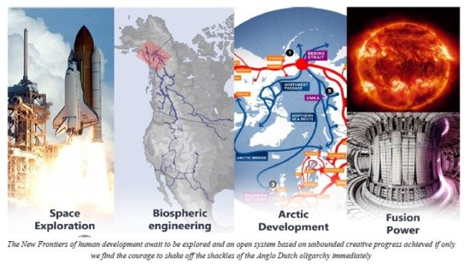
Speaking to the CPC central committee in 2016, President Xi said:
“Coordinated development is the unity of balanced development and imbalanced development. The process from balance to imbalance and then to rebalance is the basic law of development. Balance is relative while imbalance is absolute. Emphasizing coordinated development is not pursuing equalitarianism, but giving more importance to equal opportunities and balanced resource allocation.”
In an earlier speech, Xi developed this concept even further:
“We must consider innovation as the primary driving force of growth and the core in this whole undertaking, and human resources as the primary source to support development. We should promote innovation in theory, systems, science and technology, and culture, and make innovation the dominant theme in the work of the Party, and government, and everyday activity in society… In the 16th century, human society entered an unprecedented period of active innovation. Achievements in scientific innovation over the past five centuries have exceeded the sum total of several previous millennia. . . . Each and every scientific and industrial revolution has profoundly changed the outlook and pattern of world development. . . . Since the second Industrial Revolution, the U.S. has maintained global hegemony because it has always been the leader and the largest beneficiary of scientific and industrial progress.”
In a 2019 speech calling for Russia’s prioritization of fusion power as a replacement to the fossil fuel economy, President Putin expressed similar insights saying:
“It may seem strange at first, but fusion energy, which in fact is similar to how heat and light are produced in our star, in the Sun, is an example of such nature-like technologies.
“Potentially we can harness a colossal, inexhaustible and safe source of energy. However, we will only succeed in fusion energy and in solving other fundamental tasks if we establish broad international cooperation and interaction between government and business, and join the efforts of researchers representing different scientific schools and areas. If technological development becomes truly global, it will not be split up or reined in by attempts to monopolize progress, limit access to education and put up new obstacles to the free exchange of knowledge and ideas.. With their help, scientists will be able to literally see nature’s creation processes.”
So when Putin or Xi come out calling for a new economic order to replace the currently collapsing one, this is the spirit of the system he is talking about. They are talking about a system that rejects ‘predictive modelling’ using linear equations in favor of the REALITY of human creative mentation as a non-linear YET intelligible geological force of change bringing humanity into ever greater harmony with the laws of creation.

